Injury Prevention for Young Female Athletes: Information Sheet

Research has shown that Female athletes who participate in jumping and pivoting sports are 2- 10 times more likely to sustain a knee ligament injury, such as an anterior cruciate ligament (ACL) injury, than male athletes participating in the same sports¹. Approximately 80% of ACL tears occur without any contact with another player, and can occur while the athlete is landing from a jump, decelerating suddenly, or quickly changing direction.
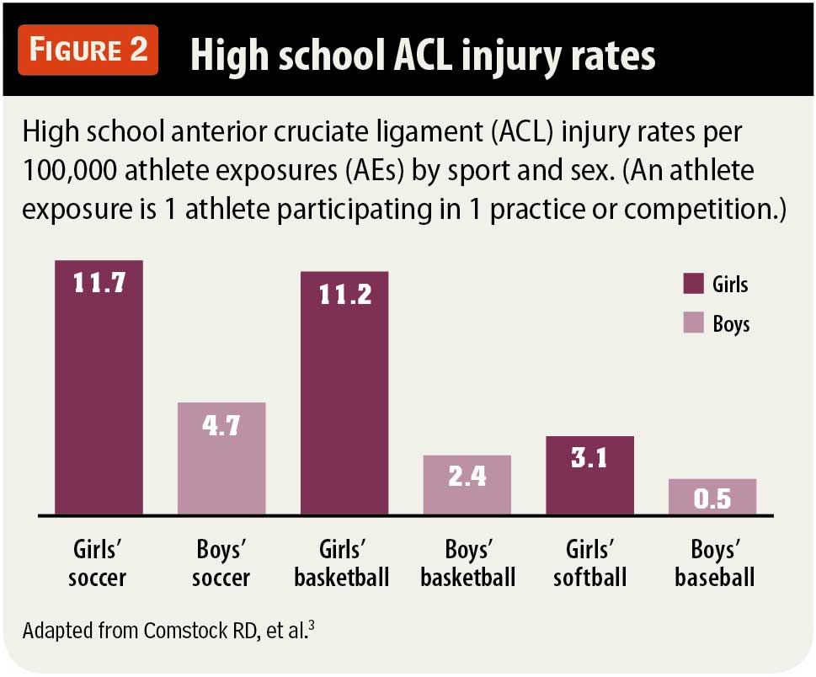
ACL injury rates for girls begin to increase at 12 to 13 years old therefore the best window of opportunity for ACL injury risk reduction may be during early pubertal maturation.
Girls’ high school sports associated with the highest rates of ACL injuries are soccer, basketball, and gymnastics, which account for 11.7, 11.2, and 9.9 injuries per 100,000 athlete exposures (an athlete exposure is 1 athlete participating in 1 practice or competition)². See Figure 2.
Another study showed that girls of this age also sustained more severe injuries. The study measured the severity of injury by number of days lost per injury.

ACL injuries have both immediate and long-term consequences for young athletes. Short-term consequences include pain and disability during the treatment phase, which involves surgery and 6 to 9 months of intensive rehabilitation before return to sports is considered. The potential consequences of an ACL injury may be more pronounced for girls than for boys. A study of high school athletes found that compared with boys in similar sports, girls were more likely to have surgery and less likely to return to sports after an ACL injury⁴.
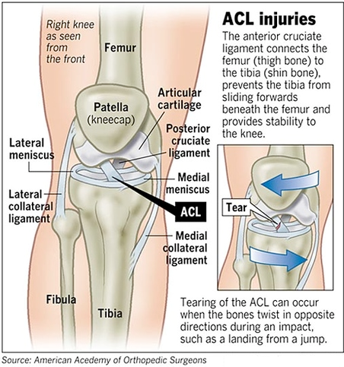

Factors that increase Female injuries:
- Hormonal
Estrogen relaxes or allows stretching of the ACL

- Neuromuscular
Girls tend to have less neuromuscular control of knee motion during athletic maneuvers

- Anatomical differences
Increased hamstring flexibility, increased foot pronation, wider pelvis and a tendency towards “knock knee” in women

Programs that have focussed on injury prevention techniques, incorporating progressive strengthening for the core and lower extremities, plyometrics, and feedback-driven technique modification, have been shown to be effective in reducing injuries in young women⁵.
These programs have also been shown to increase overall performance. Studies have shown that the benefits include increased vertical jump, improved control of dynamic load of the knee, improved balance and increased hamstring strength, power and peak torque⁶.
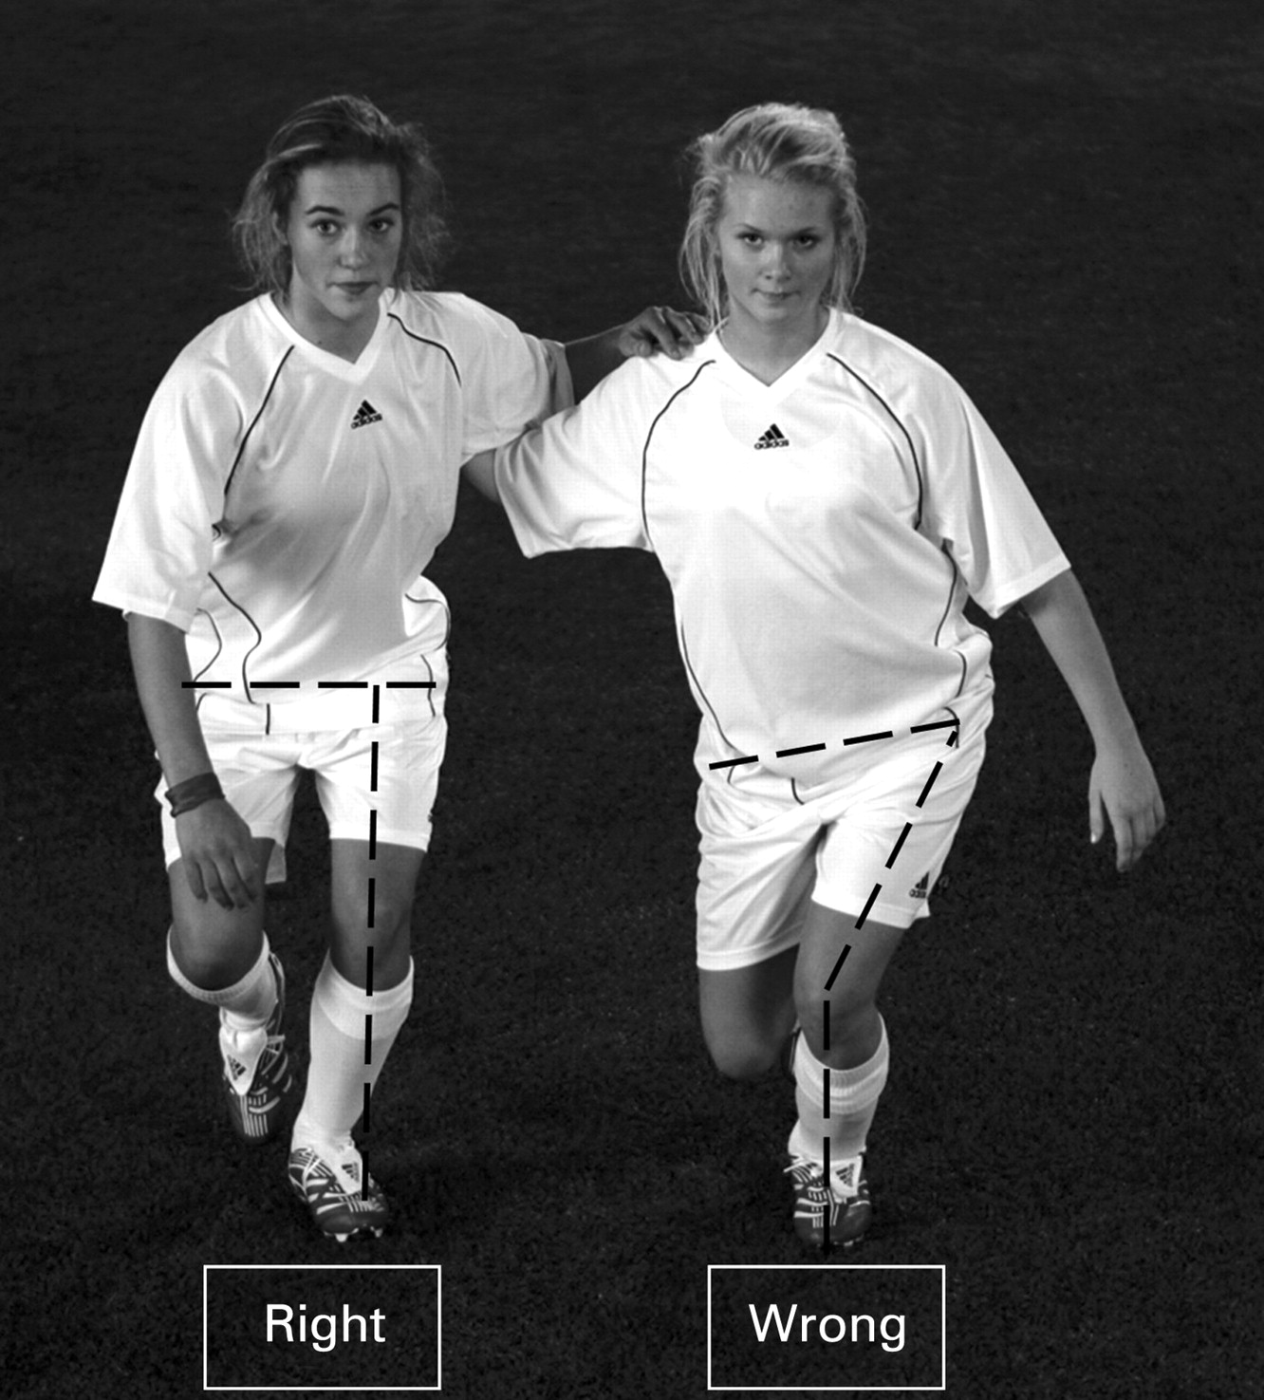
Example exercise: Single leg squat
The athlete should maintain a straight line through the hip, knee and toe. She should keep a horizontal orientation of the hips and avoid a pelvic tilt during one-legged squat balance exercises. The athlete should be encouraged to reach deep knee flexion when performing this drill⁷.
In order for these programs to be successful, prevention programs should be attended before, during and after the sports participation season in order to minimise injuries⁷.

References:
- Hewett TE; Why women have an increased risk of ACL injury. http://www.aaos.org/news/aaosnow/nov10/research3.asp
- Comstock RD, Collins CL, Corlette JD, Fletcher EN; Center for Injury Research and Policy of The Research Institute at Nationwide Children’s Hospital. National high-school sports-related injury surveillance study, United States, 2007-2008 school year; 2011-2012 school year. http://www.nationwidechildrens.org/cirp-rio-study-reports.
- McLain LG., Reynolds S.; Pediatrics Vol. 84 No. 3 September 1, 1989 pp. 446 -450
- Swenson DM, Collins CL, Best TM, Flanigan DC, Fields SK, Comstock RD. Epidemiology of knee injuries among US high school athletes, 2005/2006-2010/2011. Med Sci Sports Exerc. 2013;45(3):462-469.
- Hewett TE, Ford KR, Myer GD. Anterior cruciate ligament injuries in female athletes: part 2, a meta-analysis of neuromuscular interventions aimed at injury prevention. Am J Sports Med. 2006;34(3):490-498.
- Myer GD, Ford KR, Palumbo JP, et al. Neuromuscular training improves performance and lower-extremity biomechanics in female athletes. J Strength Cond Res 2005;19:51–60
- Renstom P.; Br J Sports Med 2008;42:394-412 doi:10.1136/bjsm.2008.048934

